27/3/17

# Ice experiment

11:00-12:20

## plan

|  |  |  |
| --- | --- | --- |
| # | Time | Sample |
| 1 | 5 | Ice Water |
| 2 | 30 | Ice Water |
| 3 | 60 | Ice Water |
| 4 | 100 | Ice Water |
| 5 | 5 | E coli in water - ICE |
| 6 | 30 | E coli in water - ICE |
| 7 | 60 | E coli in water - ICE |
| 8 | 100 | E coli in water - ICE |

## Water over time:

### Water @5s

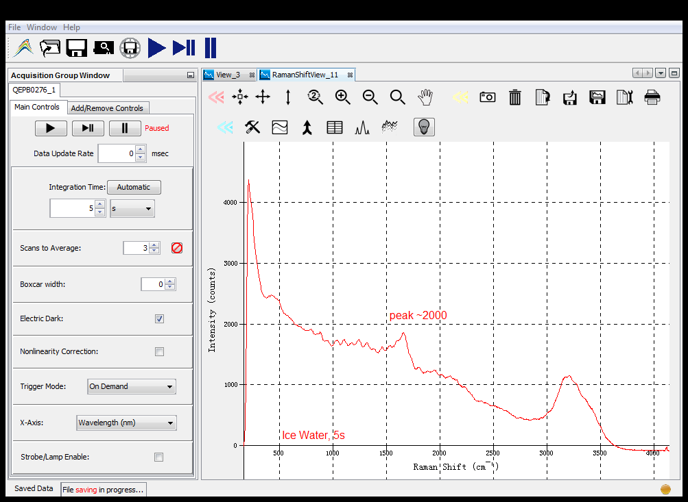

### Water @30s

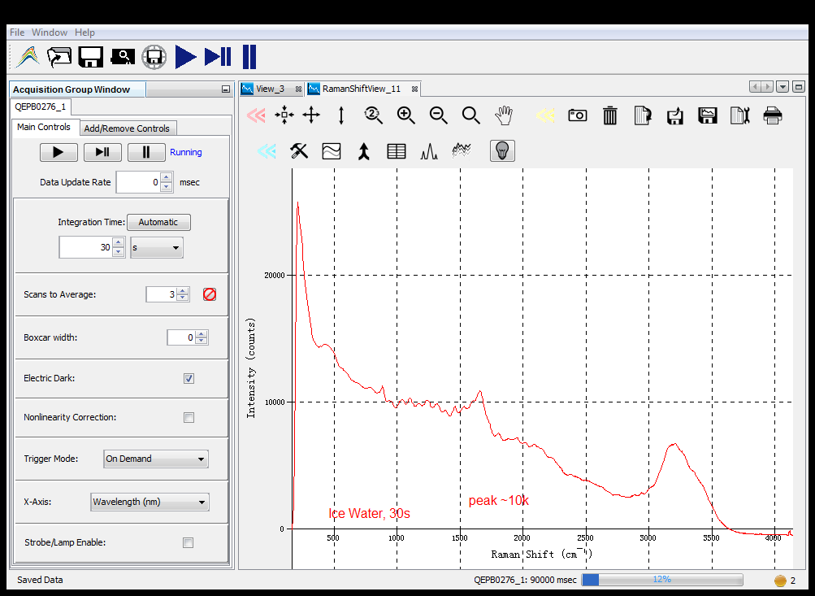

### Water @60

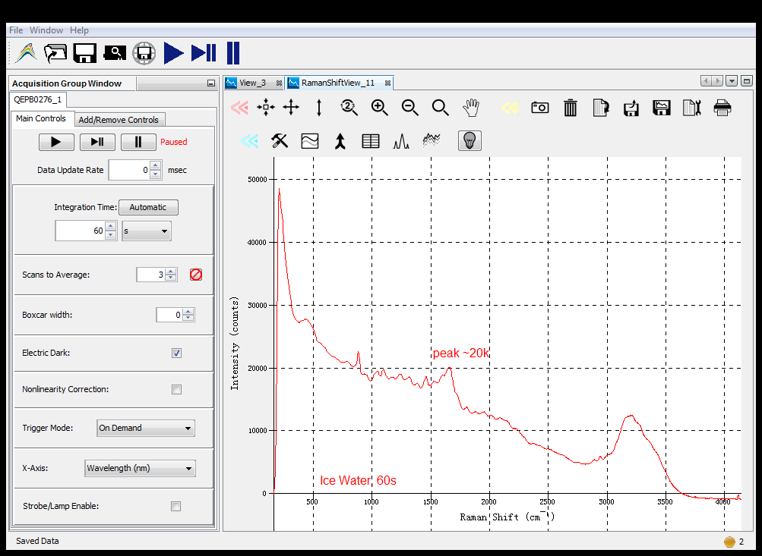

### Water @100s

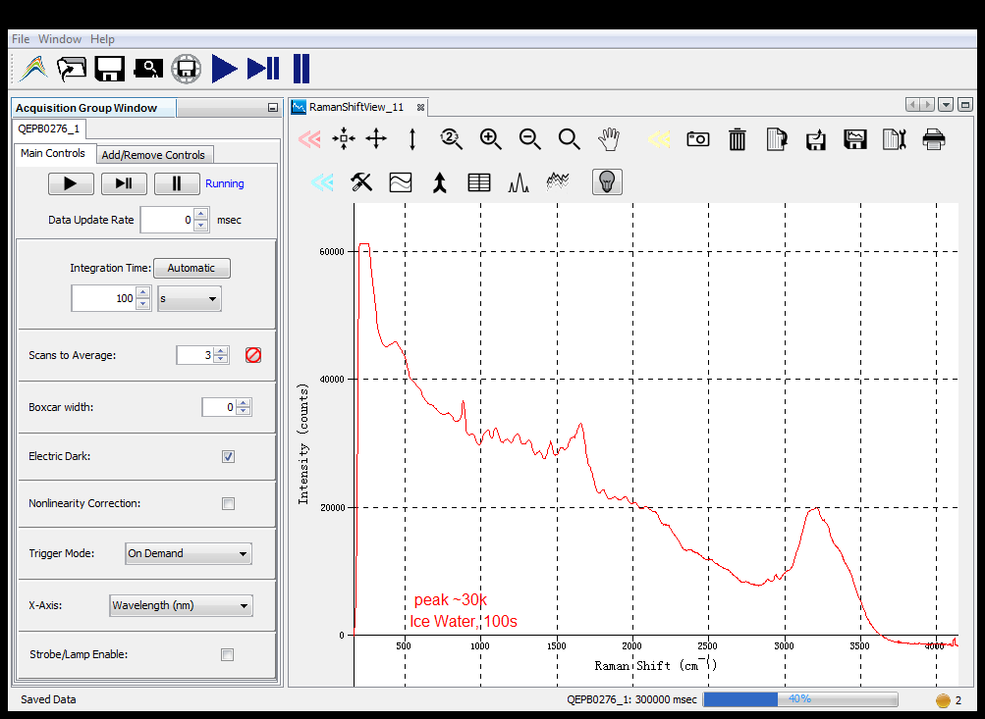

## E. coli over time

### Coli 5s

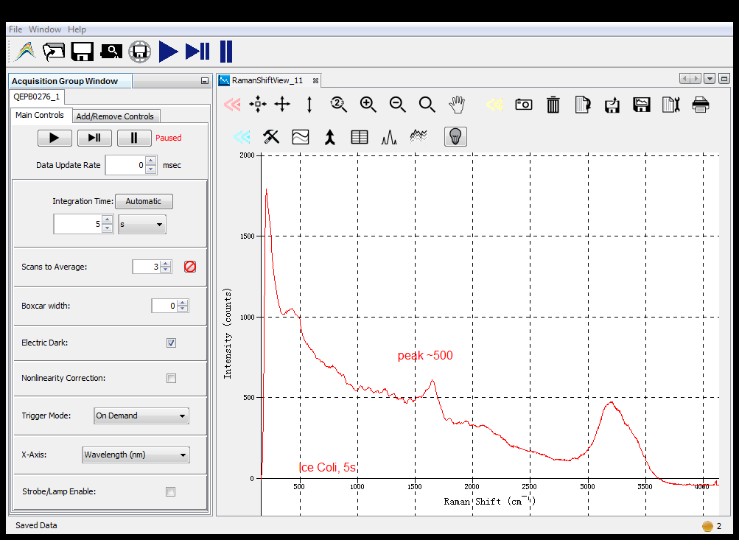

### Coli 30s

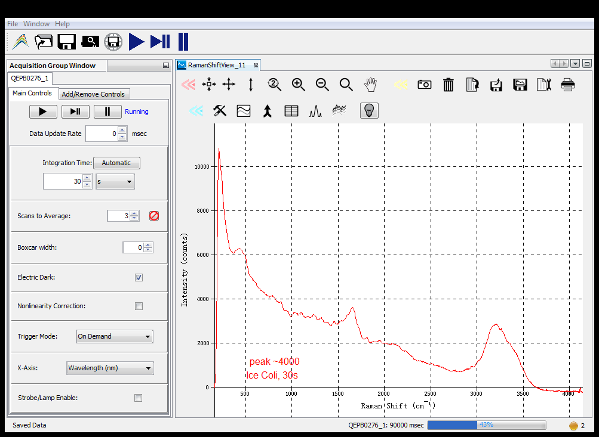

### Coli 60s

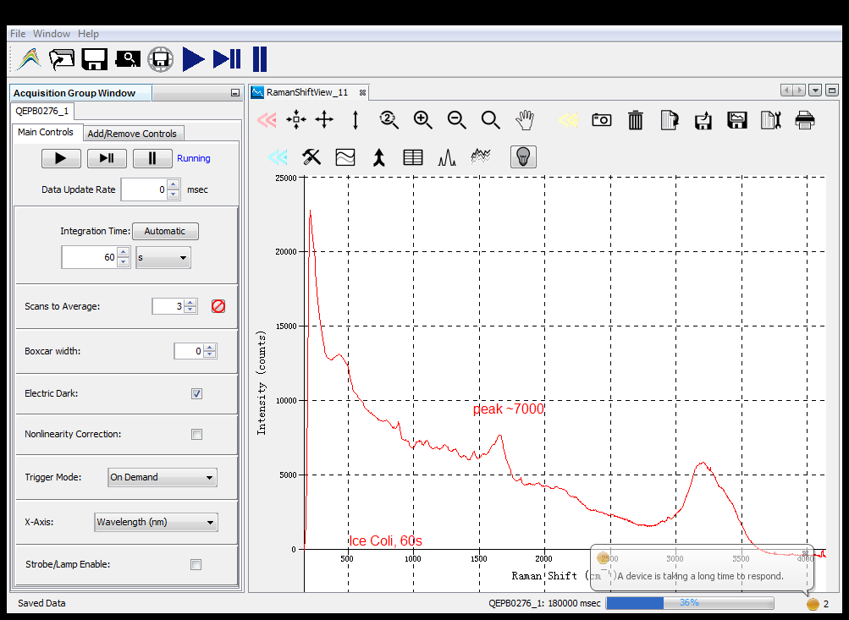

### Coli 100s

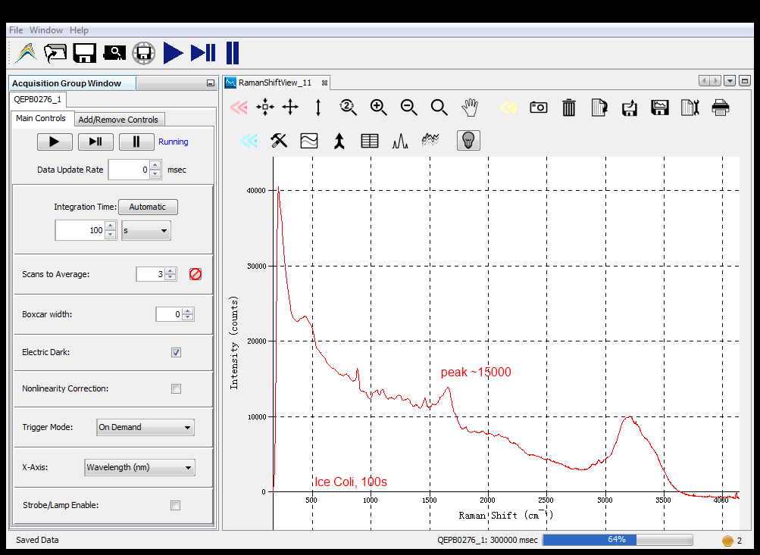

# Boiling experiment

## Plan

|  |  |  |
| --- | --- | --- |
| # | Time | Sample |
|  |  |  |
| 2 | 30 | Boil Water |
| 3 | 60 | Boil Water – only 1 run, looking for peaks |
|  |  |  |
|  |  |  |
| 6 | 30 | E coli in water - Boil |
| 7 | 60 | E coli in water – Boil  only 1 run, looking for peaks |
| 8 | 100 | E coli in water – Boil  only 1 run, looking for peaks |

### Water @30s

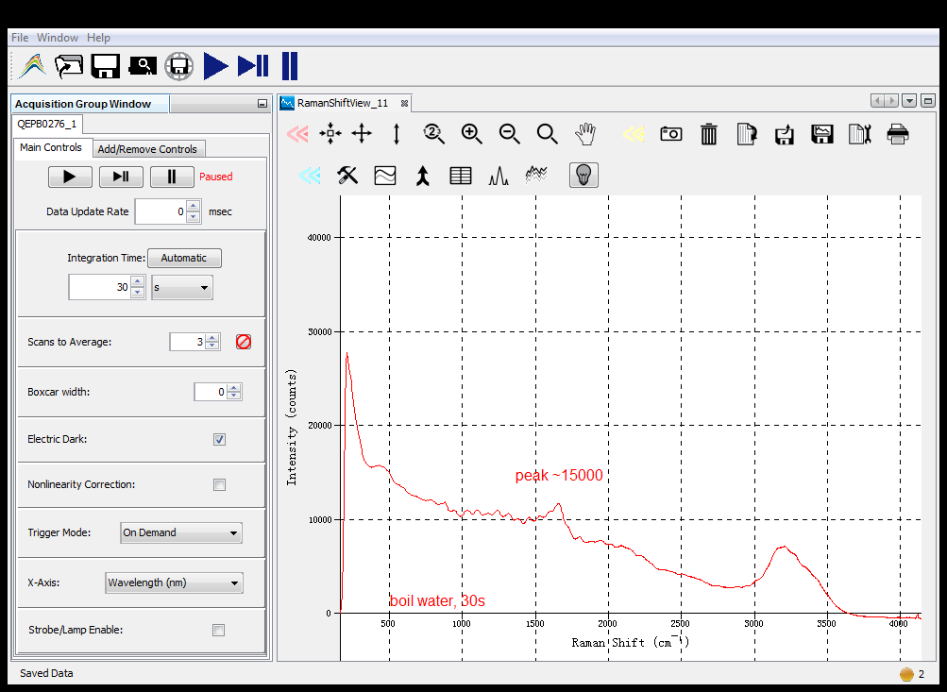

### Water @60s

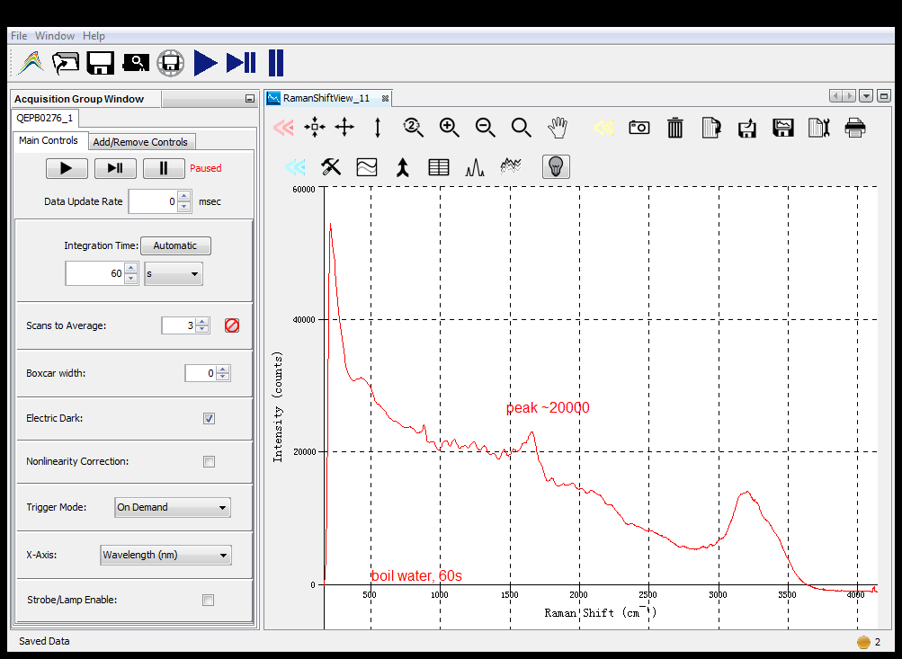

### Coli boil 30s with water overlay

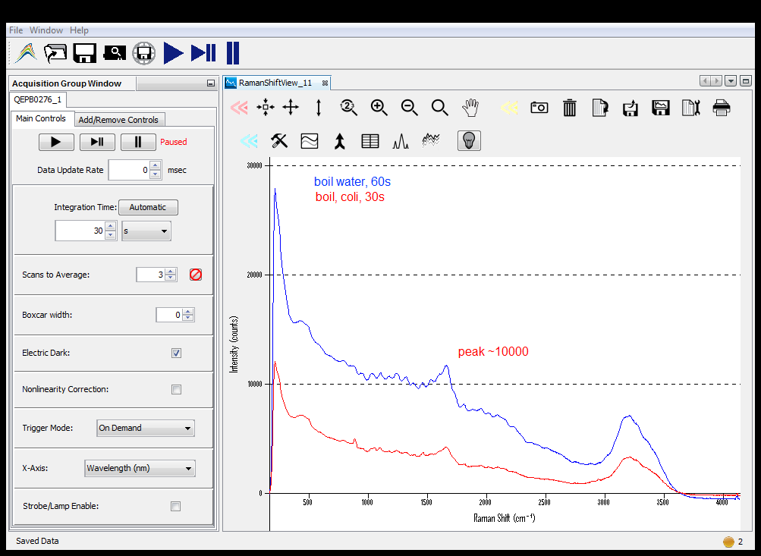

### Coli boil 60s with overlay

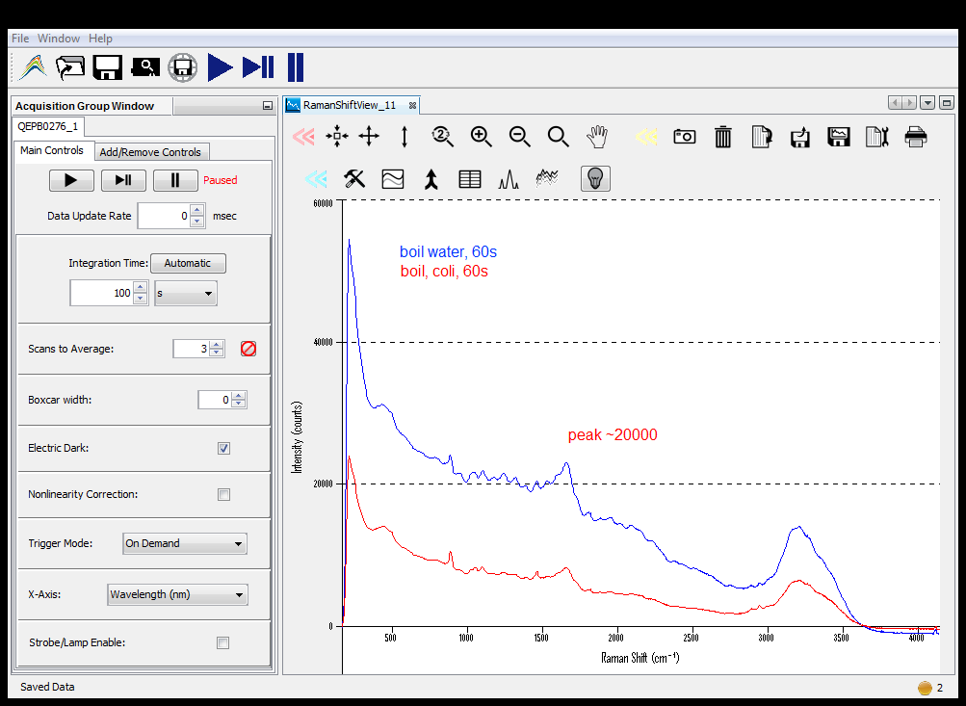

### Coli boil @100s with overlay

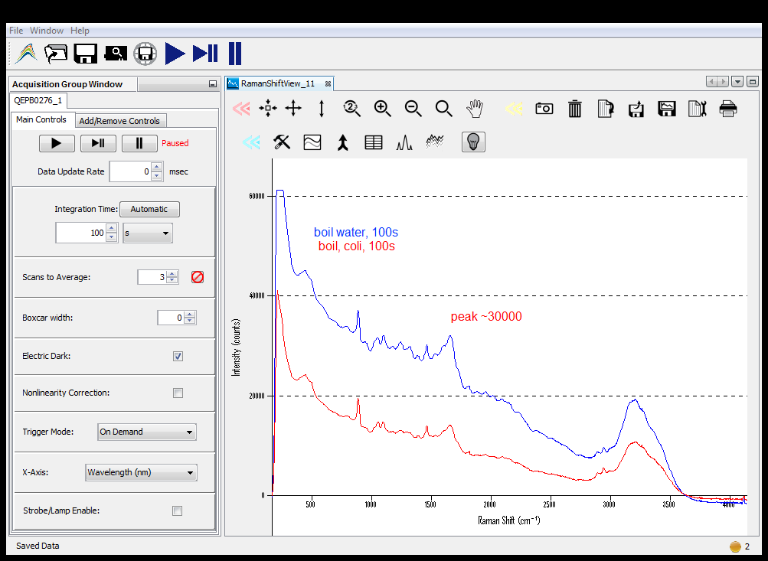

# Schmil Experiment

## Plan

|  |  |  |  |
| --- | --- | --- | --- |
| # | Time |  | Sample |
| 1 | 5 | 1 | water |
| 2 | 5 | 1.2 | water |
| 3 | 10 | 1 | water |
| 4 | 20 | 1 | water |
| 5 | 20 | 1.2 | water |
| 6 | 30 | 1 | water |
| 7 | 30 | 1.2 | water |
| 8 | 100 | 1 | water |
| 9 | 5 | 1 | coli |
| 10 | 5 | 1.2 | coli |
| 11 | 10 | 1 | coli |
| 12 | 20 | 1 | coli |
| 13 | 20 | 1.2 | coli |
| 14 | 30 | 1 | coli |
| 15 | 30 | 1.2 | coli |
| 16 | 100 | 1 | coli |